Title: Exploring Muscle Action Investigation -2
Authors: Lannie Jones and Florence Jennings

Guiding Question: How do the muscles attach to the bones make movement possible?

Standards
5.4.1 Investigate technologies that mimic human or animal musculoskeletal systems in order to meet a need.
    - Investigate the purpose of prototypes and models when designing a solution to a problem and how limitations in cost and design features might affect their construction.

Purpose: Explore how muscles move our thumbs, legs and arms. Help students understand the important idea that muscles are attached to bones, and they must bridge joints to effect movement.
OBJECTIVES
In this activity, you will
Students will demonstrate and understand how human arms, legs and thumb muscles by creating a model that simulates these movements.
- Learn to use the Force Sensor.
- Measure the changing forces as you pull and push on the Force Sensor.

You can use a Force Sensor to measure the strength of a muscle in a push or pull. In this activity, you will work with a Force Sensor to learn how it works.
MATERIALS
LabQuest
Vernier Dual-Range Force Sensor

PROCEDURE
Part I Learn About the Force Sensor
1. The Force Sensor has a switch on it. Set the switch to the +/- 50 N setting.
2. Make sure the Force Sensor is connected to LabQuest.
3. Choose New from the File menu.
4. On the Meter screen, tap Length. Change the data-collection length to 10 seconds. Select OK.
5. Do the following to collect data using the Force Sensor:
- Look at the screen and start data collection.
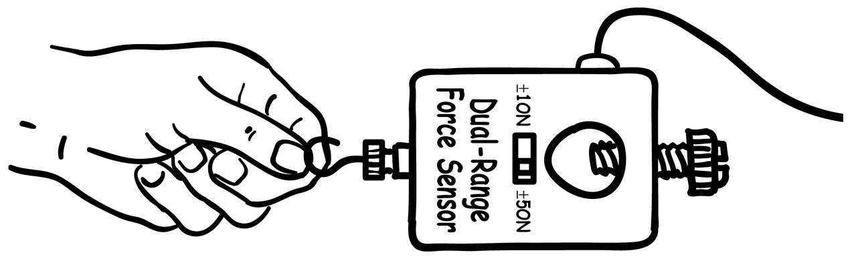
- Press very softly on the hook of the Force Sensor and watch what happens on the graph on the screen.
- Now, press hard on the hook. Watch to see how the force that is being measured is different when you pull hard on the hook.
- Now, try pulling gently on the hook with the thumb model. Watch how the force changes when you push on the hook with this object.
- Stop data collection, if data collection has not ended.
- Now, try pulling on the hook with the other end of the thumb model. Watch how the force changes when you push on the hook with this object.
- Stop data collection, if data collection has not

6. In the Observations Sheet below, write what happened to the force when you pushed gently on the hook, when you pressed strongly on the hook, and when you pulled on it.
Observation Sheet

Real Hand  Reading | Hand Model  Reading | Hand Model  Strongly pressed  Reading | Hand Model  Pulled Reading  (Using back end of thumb model)

Science QUESTIONS:
- How do the muscles attach to the bones make movement possible?
- In what way is the force reading from the thumb model similar and different from the real thumb force reading? What can you conclude from this data?

